**Create your GitHub account**

Throughout this course, you'll be using Github to practice working with repositories. In this lesson, you'll learn how to set up your Github account.

**Step 1:** Go to [Github](https://github.com/" \o "https://github.com" \t "_blank)

 in your web browser

**Step 2:** Click the Sign-up button in the top right of the screen.



**Step 3:** Enter your email address

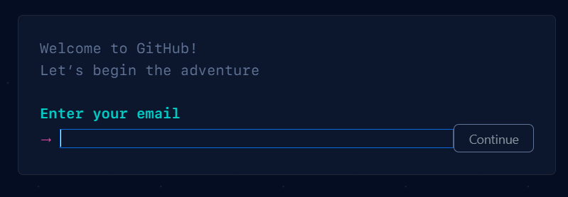

**Step 4:** Choose a strong password

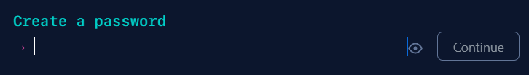

**Step 5:** Enter a username

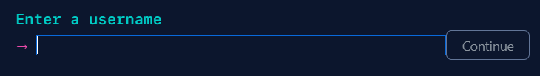

**Step 6:** Complete the security question

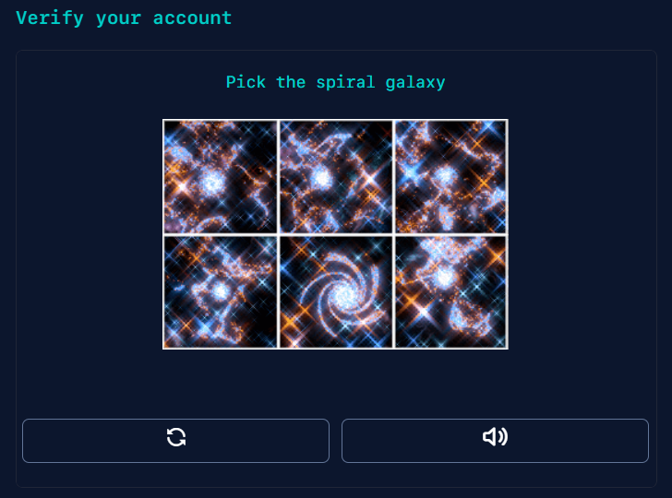

**Step 7:** Click *Create Account*



**Step 8:** You will then receive a confirmation email to confirm your address.

The email will contain a code. Enter this code on the confirmation screen.

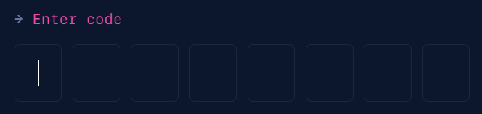

Once the code is added, you will have access to your Github account!